Abstract
This report details the design of a localization system to allow “EvilCorp” to track the location and productivity of its employees. A trilateration based radio and an inertial based localization method have been developed running on a mobile node. The radio based localization yielded good results however further work is needed to improve the reliability of the inertial system. A Kalman filter algorithm has been developed to combine the predictions from the radio and inertial systems to produce an improved position estimate. A client application has been implemented that receives the estimated position from the mobile node and displays it on an image of the testing environment.

INTRODUCTION
This report looks at the creation of a prototype system to allow “EvilCorp” to track the location and productivity of its employees.
The system consists of a mobile node tacking the location, a base station node that receives the location via a radio frequency (RF) link and a client application that records the received locations and creates a 2D visualization of the current position.
The major challenge of the project is the localization preformed on the mobile node. This is achieved using four RF beacons embedded in the environment and inertial data from an on board Inertial Measurement Unit. A position estimate is obtained from each data set and then the two estimates are combined to give an improved position estimate using a Kalman filter. The report documents the development and techniques used in each module of the solution and then results and conclusions are discussed.

Solution

Inertial position estimate

IMU Calibration
The IMU was calibrated with a sample rate of 10Hz. This was chosen so that there would be enough time between samples for RSSI localization and IMU algorithms to execute. On device initialization the offsets for x, y and z accelerations and angular velocities are sampled and stored on the device as offsets which are subtracted from subsequent readings.

Direction Cosine Matrix
A Direction Cosine Matrix (DCM) was used to store the devices orientation. Using this matrix we could convert vectors between the base frame of the device and the global frame through multiplication. This was necessary to both remove gravity from acceleration measurements as well as calculating the displacement of the device in the global frame.
The DCM was updated by measuring the angular velocity in the x, y and z axis’s at each time step, integrating these measurements to find the change in rotation, converted to a skew symmetric matrix and then multiplied by the DCM matrix. The equation below shows the update step after computing the skew symmetric matrix from the rotations, in the x, y and z.
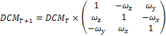

Gravity Compensation
Removing gravity from our accelerometer measurements is important as any small error can have a large impact on our calculated displacement.
To remove gravity from the acceleration measurements we first convert the measurements to the global frame by multiplying them by the DCM. We can then subtract the gravity offsets calculated on initialization from their respective components. This method relies on the DCM being very accurate as a slight error will cause gravity to effect the measurements we get.

Acceleration Orientation Calculation
Calculating the orientation using measurements from the gyroscope alone is prone to drift. This means that over time the error between the DCM and the devices true orientation in the global frame will slowly increase. Because gravity is constant in the global frame and can be detected in acceleration measurements we can use this to calculate the devices absolute orientation in the global frame. This method will not be affected by drift as gravity is constant.
To calculate this the device first takes and stores the off-sets of gravity in the x, y and z directions with the device being level, x and y plane being perpendicular to gravity.

Because we know that gravity should only be in the direction we create a vector that should be in the form. To do this we subtract the off sets from only the x and y acceleration readings and then store in a vector.

Using these three values we then calculate the Roll () and Pitch () of the device. This is calculated using the below equations.
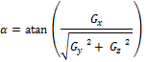
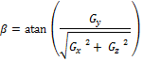

There are two draw backs with this method. First we cannot calculate the yaw, angular displacement about the z axis and second due to the accelerometer being prone to high frequency noise so will these angles if the device is not stationary. To account for the high frequency noise we chose to implement a complementary filter which is discussed in the next section.

Complementary Filter
A Complementary Filter was used to calculate the angle of the device by fusing both angular displacement measurements over time and the orientation calculated using acceleration as stated in the previous section. Using this allowed us to remove the high frequency noise from the acceleration measurements and the drift from the gyro measurements.

Error Correction
As the DCM is updated, due to small errors the planes do not stay orthogonal to one another. To correct this after each update we calculate the orthogonal error between the X and Y plane by taking the dot product of the two vectors. We then recalculate the X and Y planes distributing the error evenly between them. Finally the Z plane is calculated by taking the cross product of the resulting X and Y planes. After this is done the DCM matrix is then re-normalized.
It was planned to use the angles calculated by the complementary filter to remove the drift in the DCM but this functionality was not implemented in time.

Displacement Calculation
After an acceleration measurement had been converted to the global frame it was then integrated to give the velocity and then again for displacement. It was found that a very small error in acceleration would lead to exponential errors in the displacement calculated and due to not being able to correctly correct the drift in our DCM we switched to operating with the device in a fixed global orientation. This allowed gravity to be successfully and consistently removed from device readings. However we found that errors in the integration of acceleration caused velocity errors and we were unable to successfully compensate for these.

If the IMU was working we had planned to measure small changes in displacement over time and add these changes to the output of the Kalman filter. After the new position was calculated the IMU positions would then be reset. This was to remove any continued error in the IMU calculation.

Radio position estimate

- Design Considerations

As suggested by the course notes, a trilateration-based algorithm was used for beacon-based localisation. A distance approximation is calculated from the ED (Energy Detection) value of the received signal. This value was used over the RSSI (Received Signal Strength Indicator) value for a several reasons. Firstly, the value is calculated by averaging several RSSI values to get a more normalized result. The ED value is also higher resolution of 1.03dB compared to the 3.1dB of RSSI. Lastly, the ED value is also much easier to access, as it is automatically included in the message frame that is given to the processor upon receiving a message.
The distance is calculated through a linear approximation equation based on experimental analysis of distance versus ED value. The results of this are fairly inaccurate, however, as the measured ED varied a great deal based on other factors such as orientation and the proximity of other objects, as well as some random variation. Due to constraints on the project, it was not possible to account for all of these variables, so some guesswork had to be used in the formulation of the approximation. Despite this, the calculated equation gives a good enough approximation when combined in the trilateration algorithm to give a meaningful position estimate.
As a result of these unreliable distance approximations, a large emphasis was placed on making the trilateration algorithm as tolerant as possible to inconsistent and unreliable inputs. Although the output can only be as good as the input (garbage in, garbage out), the algorithm can be designed to exploit redundant data, and mitigate the effect of single, but wildly wrong values. Some matrices used in an example trilateration algorithm are shown in equation (1). The weakness of this algorithm is revealed by the fact that x_{n} or y_{n} (the x or y distance to a particular beacon) is in every single term of both matrices. This obviously shows a bias towards that particular value, and if that measurement were to be completely off the true value, then the algorithm would give a completely wrong answer.
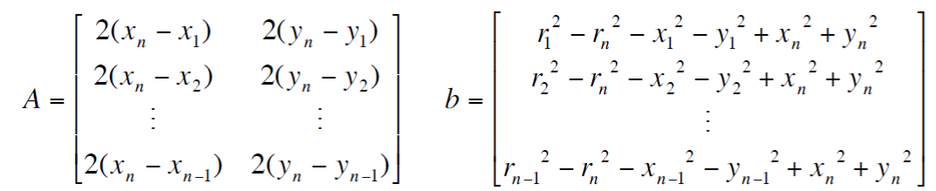(1)

Although the target for this application is an embedded platform, in order to find the “best answer” to this problem if given unlimited resources, the higher-level programming language Python was used as a development tool. The premise of the so-called “best answer” is simple; each beacon provides a probability distribution (modelled as gaussian for simplicity) of the mobile node’s expected location in a radius around the beacon in 2D space. The distributions generated from each beacon are added together, and the point in 2D space with the highest value is output as the most likely position. A graphical representation is shown in Figure 2, where the graph on the left shows the probability distribution generated from a single beacon, and the graph on the right shows the sum of the distributions from four of those beacons. The peak of this graph is the estimated position of the mobile node.

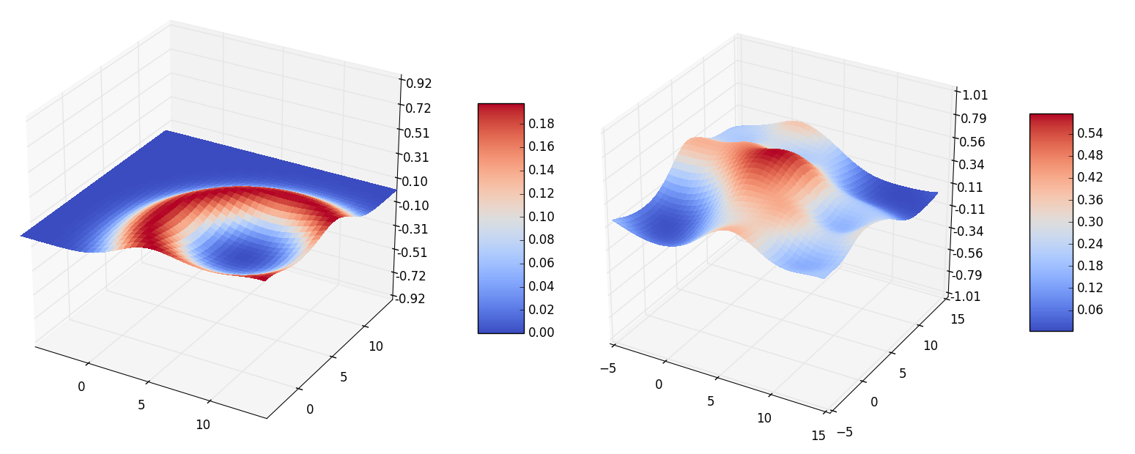
Figure 1: Localisation method based on gaussian probability distributions, plotted using python’s matplotlib library. σ = 2m

The results from this algorithm are very good. If a large standard deviation is used for the probability distributions, even with a single very inaccurate (or multiple somewhat inaccurate) distance estimates, the algorithm can still generate a relatively accurate answer. However, the computation power required to generate this answer is quite excessive, requiring a two-dimensional mesh grid and a complex calculation for each cell in the matrix, as well as for each additional beacon. Because of these requirements, implementing this algorithm on the mobile node would be impractical due to processing speed and memory restrictions. However, the visualisations provided some insights into how some of the more computable aspects of the beacon measurement radii can be used as position estimators.
Of particular interest are the intersects between the radii. In an ideal world, the radii would all intersect at the same point, and that would automatically be calculable as the mobile node’s position. However, because of the aforementioned inaccuracies, the intersection points will all be slightly different and therefore will not converge at the exact same spot. In addition to this, because there are two intersects between the radii there must also be a way to choose between those. (In cases where the radii do not intersect, an approximation of where they ‘would’ meet can be calculated by proportionally extending the radii to meet each other. This results in a single intersect, so does not need to be chosen between.) Nonetheless, it is still possible to approximate the mobile node location based off of the intersects by examining how the intersects are grouped. Figure 3 shows an example of how the radii intersects can relate to the receiver's position.
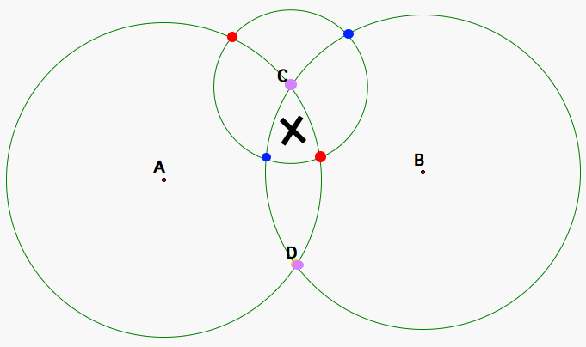
Figure 2: Intersections between circles shown in coloured pairs. An estimate of the corresponding mobile node location is indicated by the black ‘X’

- Algorithm Details

The algorithm implemented on the mobile node is described below. Each of the beacons’ ED values are first converted into distance approximations. Each node is then compared with the next node in the sequence to find the intersects of those radii. For example, in the four-node scenario used throughout the project, node one is compared with node two, node two with node three, node three with node four, and node four back with node one. This ‘neighbour comparison’ method was used instead of comparing with every single other node due to the much better scalability. Although with four beacons, only 2 extra comparisons would be required (up 50% from 4) to compare each node with all others, the number of required combinations would increase exponentially with the number of nodes. For example, with ten nodes a total of forty-five intersection calculations would have to be made (using the combination formula _{n}C² where n is the number of nodes).
If two intersects of the radii are found, then the one that approximates the node’s position must be chosen. These can be easily determined by a human visually, by looking for those points that are grouped together. However, this kind of search is not so simple for a computer. Clustering algorithms that groups points together based on their proximity also have a high complexity, and scale poorly with an increased number of nodes (and therefore intersections). In order to circumvent this, a simple ‘cheat’ was used by using a position estimate to determine which of the intersects are likely to correlate with the calculated position. This means that the algorithm requires an additional input, but makes it simpler and more scalable. The last step is the simplest - each of the chosen intersects points are averaged, and the result is used as the output of the localisation function.

Kalman Filter
The Kalman Filter in our implementation uses the old position as the prediction (due to the IMU not being used, this is the best guess for where we would be), and the trilateration output as the measurement. The prediction is given a standard deviation of 1500mm, while the measurement is set as 2500mm. These large standard deviations reflect the low reliability of each of the values. The prediction assumes that there is no movement, while the trilateration output can be very inconsistent and changeable. By setting the prediction to have a lower spread, however, the calculated position is prevented from moving around wildly. This has the benefit of smoothing the results of the trilateration, but means the readings can lag behind when moving at higher velocities.
The Kalman filter uses the formulas shown in Equation (2). As the problem is in two dimensions, the formula for the fused mean is applied to both the x and y dimensions.
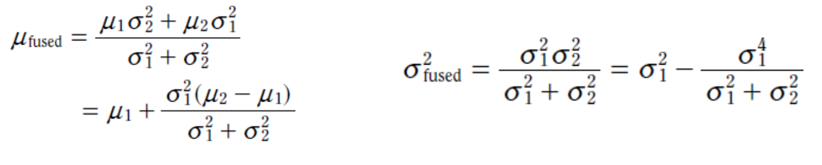(2)

Client Application
The client application running on a PC talks via serial (USB) to the base node which in turn talks to the mobile node over the RF link. The base node communicates the current position estimate it has received for the mobile node. The process running in the client application is shown below,

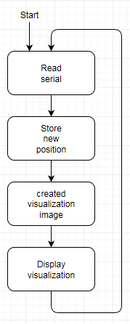
Figure 3

To begin the new position estimate is read from serial and the new coordinate is appended onto the position history file (history.txt) for this session. Next a visualization image is created using the new position to place the mobile node onto a layout of the testing environment. The four beacon positions are also placed on the image and can be adjusted if the beacon location is changed. Additionally the new x,y position is displayed in meters on the visualization image. Finally the updated image is loaded and displayed for the user, shown below in Figure 4,

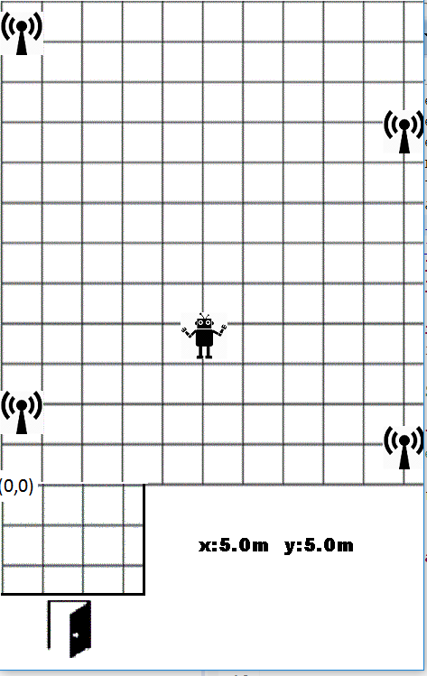
Figure 4

On the visualization the origin is shown in the bottom left with (0,0). The current position of the mobile node is displayed as a robot character and the four beacons are transmitter icons. The environment is sectioned into grids, each line in the x and y axis represents one meter with total environment being 10.6m x 15m. The alcove by the door is negative on the y-axis measuring 3.3m x 2.9m.

Coding challenges (Communication)

One major challenge when implementing the client application was passing the position data over the RF link and then over the serial interface. From the mobile node the position is packaged into the MAC message frame, the 16 bit x and 16 bit y coordinates are each placed in two bytes. In the MAC frame the x values are sent in byte 9 and 10, the y position is in byte 11 and 12. The RF message is received in the base station, here the appropriate bytes for x and y must be taken from the message frame, each rejoined into a single integer and sent over serial to the client application. It is important that the same number of digits are sent for each x,y coordinate over serial and that each set is clearly separated from the previous/next. The C langue allows the sent integers for x and y to be specified as a fixed number of digits, even if the required number is less then specified. For this application it was specified that each x and y value always be 5 digits, operating in mm this allowed the entire 15m (15000mm) length of the environment to be described, up to a possible 100m (99,999mm). Before each ten digit x,y coordinate a “*” is sent to clearly define the start and end of each position. In the client application the serial is received one digit at a time, knowing the order of the data after the “*” is received the application can recreate the single x and y value, appropriately weighting the most to least significant digits.

testing and validation
Each section of the localization solution was accessed during development for usability and reliability.
- The radio trilateration localization was found to have an accuracy to be within 2m standard deviation of the actual position inside the main area (room). With some success in locating the node when in the adjacent room.
- The IMU position estimate based on the accelerometer showed promising results when located in a stable flat position such as on a chair so that the gravity component could be eliminated. In its present state the gyro orientation wasn’t reliable enough to totally eliminate gravity in a non-stable carriage. Due to the testing requirement that the mobile node be carried it was decided for the solution demo that the IMU estimation not be included in operation.
- The visitation client was reliably run receiving and displaying the estimated position from the mobile node.

Future work
For this project we were happy with the results achieved through RSSI localization but the results from the IMU methods were not complete to a satisfactory level. Future work involves adding the drift removal from the DCM matrix using the output from the complementary filter and correcting for velocity error. From here we would incorporate these reading into the Kalman filter and expect this to produce even more accurate results.

conclusion
In this project a trilateration based radio localization method has been developed running on a mobile node, with a standard deviation from the actual position of approximately 2m. Additionally an inertial based system has been developed using an accelerometer whose output can be double integrated to find change in position. A gyro is used to orientate the accelerometer onto the global reference frame and eliminated the effects of gravity. Further work is needed to improve the reliability of the inertial system. A Kalman filter algorithm has been implemented to combine the predictions from the radio and inertial systems to produce an improved position estimate. A client application has been developed that receives the estimated position and displays it on an image of the testing environment.

